
HC BILL 28-4
Christmas Holiday Act of 2026
An Act to establish December 25th as Christmas, an official national holiday throughout the Totemian Empire, and amend Title 1, Chapter 5, Article 4 of the Civil Code of the Totemian Empire accordingly.
BILL · 28TH TOTEMIAN PARLIAMENT
PRIMARY SPONSOR
Nuxart
Member of the House of Commons · The Birthday Party
Introduced October 11th, 2026

Christmas Holiday Act of 2026
Introduced By: Nuxart (The Birthday Party)
Date: October 11th, 2026
Be it enacted by the Emperor’s most Excellent Imperial Majesty, by and with the advice and consent of the Lords, and Commons, in this present Parliament assembled, and by the authority of the same, as follows:
Long title
An Act to establish December 25th as Christmas, an official national holiday throughout the Totemian Empire, and amend Title 1, Chapter 5, Article 4 of the Civil Code of the Totemian Empire accordingly.
Chapter 1 - Christmas Holiday Establishment
Title 1, Chapter 5, Article 4 of the Civil Code of the Totemian Empire is amended by inserting immediately after Section 11 and before the final sentence concerning Imperial Order 44 the following new Section 12:
AMENDING TEXT
Section 12: Christmas
December 25th shall be observed as Christmas throughout the Totemian Empire and shall be recognized as an official national holiday.

END OF BILL

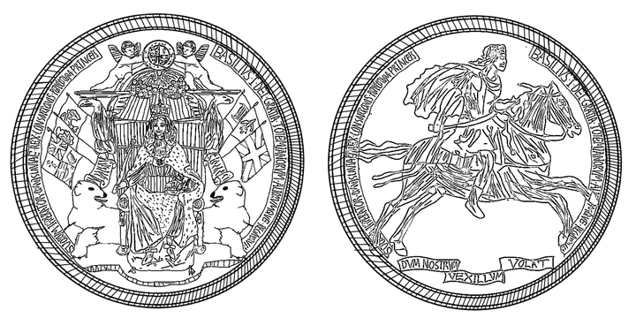
UNDER THE GREAT SEAL

