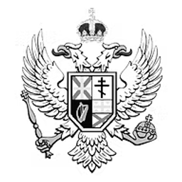
HC BILL 28-1
Holiday Act of 2026
An Act to designate October 31st as Halloween, December 31st as New Year’s Eve, January 1st as New Year’s Day, and April 22nd as Earth Day; establish each as an official national holiday throughout the Totemian Empire; and amend Title 1, Chapter 5, Article 4 of the Civil Code of the Totemian Empire accordingly.
BILL · 28TH TOTEMIAN PARLIAMENT
PRIMARY SPONSOR
Nuxart
Member of the House of Commons · The Birthday Party
Introduced October 5th, 2026

Holiday Act of 2026
Introduced By: Nuxart (The Birthday Party)
Date: October 5th, 2026
Be it enacted by the Emperor’s most Excellent Imperial Majesty, by and with the advice and consent of the Lords and Commons, in this present Parliament assembled, and by the authority of the same, as follows:
Long Title of the Bill
An Act to designate October 31st as Halloween, December 31st as New Year’s Eve, January 1st as New Year’s Day, and April 22nd as Earth Day; establish each as an official national holiday throughout the Totemian Empire; and amend Title 1, Chapter 5, Article 4 of the Civil Code of the Totemian Empire accordingly.
Statement from Nuxart
This bill was created primarily, because of Halloween, but I decided to eventually include other holidays such as the New Year celebrations and Earth Day to appease the woke liberals.
Thank You.
Chapter 1 - Halloween Holiday Establishment
Title 1, Chapter 5, Article 4 of the Civil Code of the Totemian Empire is amended by inserting immediately after Section 7 the following new Section 8:
AMENDING TEXT
Section 8: Halloween
October 31st shall be observed as Halloween throughout the Totemian Empire and shall be recognized as an official national holiday.

The final sentence of Title 1, Chapter 5, Article 4 is repealed and replaced with the following:
AMENDING TEXT
Sections 1 through 7 of this Article codify Imperial Order 44.

Chapter 2 - New Year Holiday Establishment
Title 1, Chapter 5, Article 4 of the Civil Code of the Totemian Empire is amended by inserting immediately after Section 8 the following new Sections 9 and 10:
AMENDING TEXT
Section 9: New Year’s Eve
December 31st shall be observed as New Year’s Eve throughout the Totemian Empire and shall be recognized as an official national holiday.
Section 10: New Year’s Day
January 1st shall be observed as New Year’s Day throughout the Totemian Empire and shall be recognized as an official national holiday.

Chapter 3 - Earth Day Holiday Establishment
Title 1, Chapter 5, Article 4 of the Civil Code of the Totemian Empire is amended by inserting immediately after Section 10 the following new Section 11:
AMENDING TEXT
Section 11: Earth Day
April 22nd shall be observed as Earth Day throughout the Totemian Empire and shall be recognized as an official national holiday.

END OF BILL

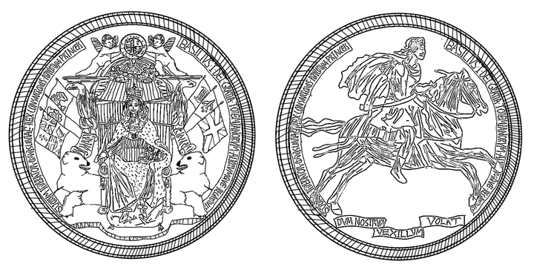
UNDER THE GREAT SEAL

