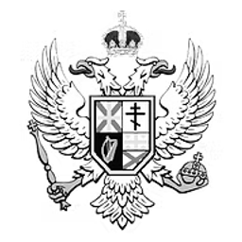
HC BILL 21-1
Sanctity of Structure Act
An Act to protect the imperial legacy and artistic vision of The Architect, whose works enrich the cultural fabric of the Totemian Empire.
BILL · 21ST TOTEMIAN PARLIAMENT
PRIMARY SPONSOR
Potato Shadowlorde
Member of the House of Commons · Independent (No Party)
Introduced May 1st, 2025
Be it enacted by the Emperor’s most Excellent Imperial Majesty, by and with the advice and consent of the Lords, and Commons, in this present Parliament assembled, and by the authority of the same, as follows:
Summary:
This decree shall establish the permanent protection of all architectural creations, structures, and artifacts designed, constructed, or claimed by Nonsense, hereafter referred to as “The Architect.” No citizen, visitor, or official—regardless of rank or position—shall alter, damage, or repurpose any element of these creations without express, written consent from The Head of Infrastructure himself.
Article I – Definition of Protected Works:
The works protected by this decree include, but are not limited to:
All structures, landscapes, and artistic designs personally conceived, constructed, or declared by The Architect.
This protection is retroactive, applying to all past and future creations, regardless of location within the Empire’s borders.
Article II – Enforcement & Consequences:
Defacement of an Imperial Monument is hereby classified as a high crime against cultural heritage.
Offenders shall be subject to the following penalties:
Full restoration of any damage inflicted.
A formal apology before the Imperial Court.
A temporary demotion to menial labor, including but not limited to stone-polishing, brick-laying, or quarry work.
Repeat offenders shall be trialed under law and may face exile or permanent silence for a period of 7 moon cycles.

Article III – Exemptions & Disputes:
A formal dispute may be raised only if a structure threatens public safety, violates sacred ground, breeches contract, or causes other issue with the Emperor.
Disputes shall be mediated by the Privy Council and must be witnessed by the Emperor
Purpose:
To protect the imperial legacy and artistic vision of The Architect, whose works enrich the cultural fabric of the Totemian Empire. This decree serves to maintain the integrity and honour of the Empire’s architecture and ensures that no creation, once made, shall fall into ruin or be defiled by those unworthy of its preservation.
END OF ACT
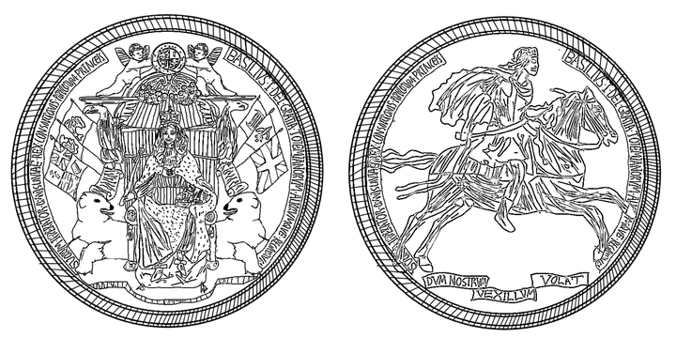
UNDER THE GREAT SEAL

