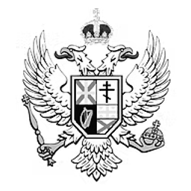
HC BILL 23-2
Communist Parties Prohibition Act
An Act to prohibit communist political parties and organizations within the Empire.
BILL · 23RD TOTEMIAN PARLIAMENT
PRIMARY SPONSOR
Andre von Juras
Member of the House of Commons · Independent (No Party)
Introduced December 26th, 2025
Be it enacted by the Emperor’s most Excellent Imperial Majesty, by and with the advice and consent of the Lords, and Commons, in this present Parliament assembled, and by the authority of the same, as follows:

Chapter 1 – Definitions
1. “Communist party” means any political party or organisation advocating communist ideology or governance.
Chapter 2 – Prohibition
1. The formation, operation, or support of any communist party or organisation is prohibited.
2. All existing communist parties or organisations are hereby dissolved.
Chapter 3 – Enforcement and Commencement
1. This Act shall be enforced by Imperial authorities.
2. This Act shall come into force upon Imperial assent.
END OF ACT
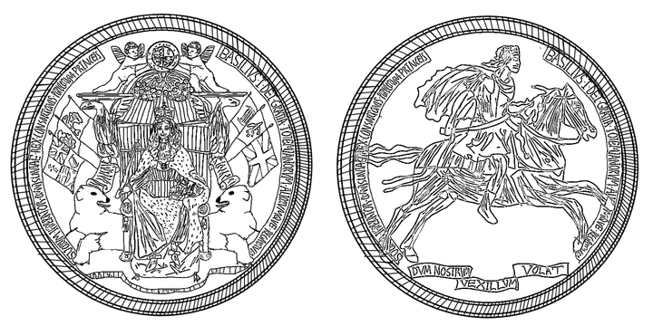
UNDER THE GREAT SEAL

